Docker-01.

- Setup a virtual machine using Ubuntu image.
1. Launch an Ubuntu VM on AWS
- Log in to the AWS Management Console.
- Go to EC2 → Instances.
- Click Launch instances.
- Enter a name, for example:
Ubuntu-VM
- Under Application and OS Images (AMI):
  - Select Ubuntu
  - Choose Ubuntu Server 24.04 LTS (64-bit)
- For Instance type, choose a small instance suitable for your account/free-tier eligibility.
- Under Key pair:
  - Select an existing key pair, or
  - Create a new key pair.
  - Download the .pem file and keep it safe.
- Under Network settings, allow:
  - SSH — TCP 22 — My IP
If you need to access a web application later, you can additionally allow:
  - HTTP — TCP 80
  - HTTPS — TCP 443
- Leave the remaining settings at their defaults unless your lab requires something specific.
- Click Launch instance.
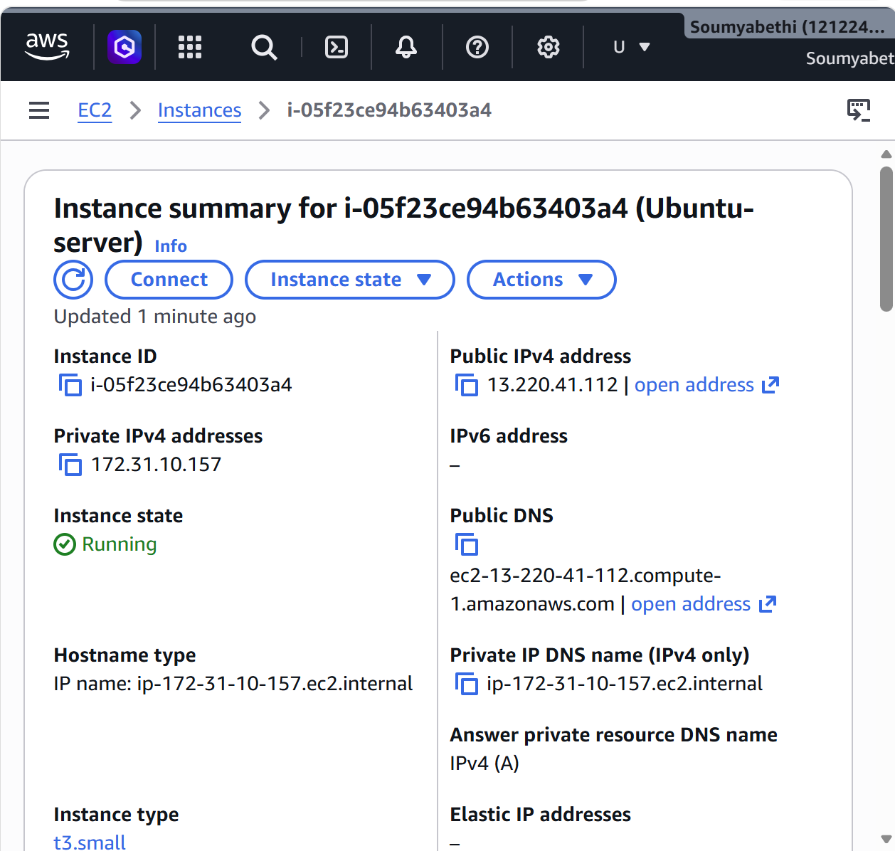
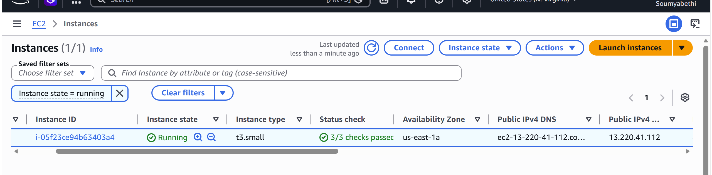
2. Verify the VM
After the instance becomes Running:
- Copy its Public IPv4 address.
- On your Windows machine, open Git Bash or PowerShell.
- Move to the folder containing your .pem file.
For Git Bash:
chmod 400 your-key.pem
Then connect:
ssh -i "your-key.pem" ubuntu@<PUBLIC-IP>
For example:
ssh -i "Ubuntu-testing.pem" ubuntu@13.234.XX.XX
Ubuntu's default SSH username is:
ubuntu
3. Confirm Ubuntu is working
After login:
whoami
Expected:
ubuntu
Check OS:
cat /etc/os-release
Check kernel:
uname -r
Check IP:
ip addr
Update the system:
sudo apt update
Then:
sudo apt upgrade -y
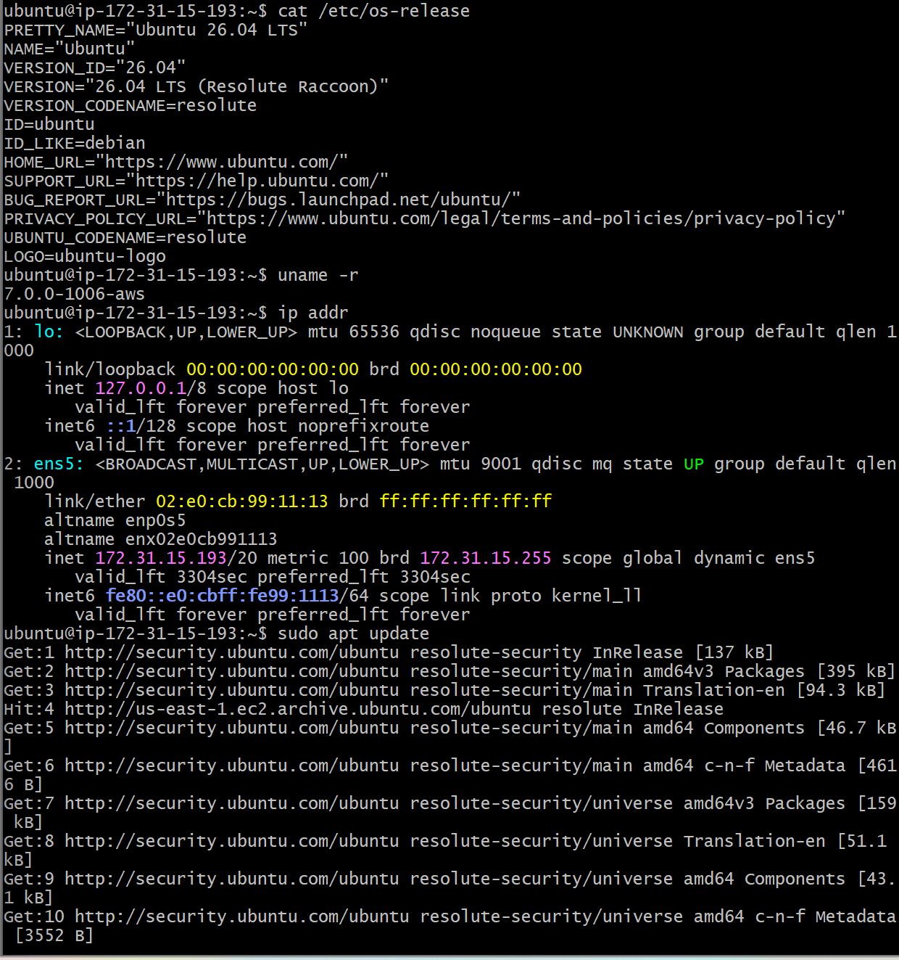

- Install docker on ec2.

First connect to your Ubuntu EC2:

ssh -i "your-key.pem" ubuntu@<PUBLIC-IP>
Step 1: Update packages
sudo apt update
sudo apt upgrade -y
Step 2: Install Docker
sudo apt install docker.io.y
Step 3: start Docker
sudo systemctl start docker
sudo systemctl enable docker
Step 4: Verify docker
docker –version
Step 5:Run a test container
sudo docker run hello-world

Step 6: Run Docker without sudo
By default, Ubuntu requires sudo for Docker commands. Add the ubuntu user to the Docker group:

sudo usermod -aG docker $user
exit
SSH back into the EC2:
Now test:
docker ps
If it works without sudo, your Docker setup is complete.

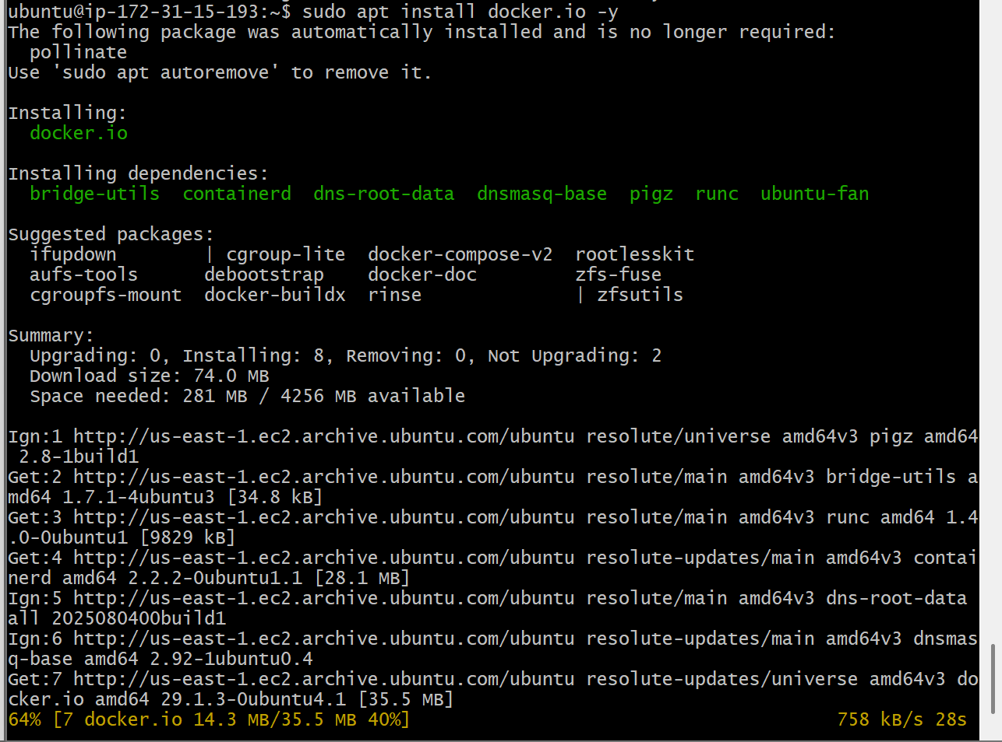
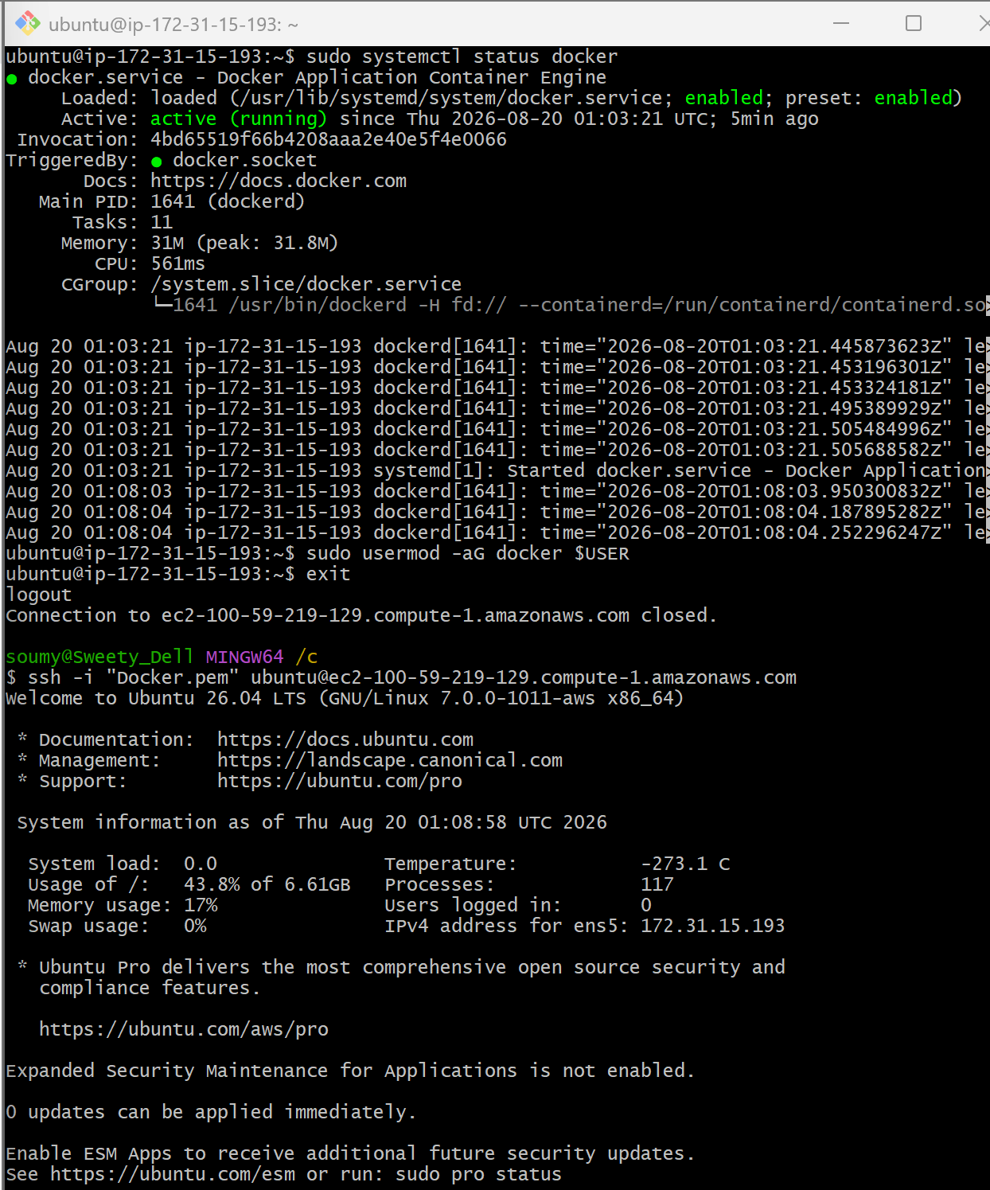

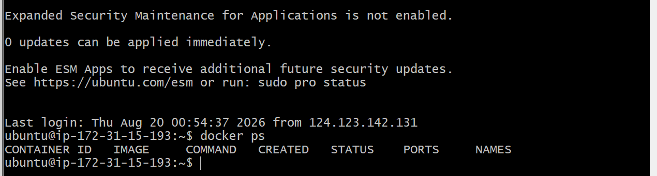
- Pull 5 docker images. (nginx, Apache tomcat, ubuntu, Jenkins, SonarQube)
- Check Docker is running
- docker --version
- docker ps
- If Docker isn't running:
- sudo systemctl start docker
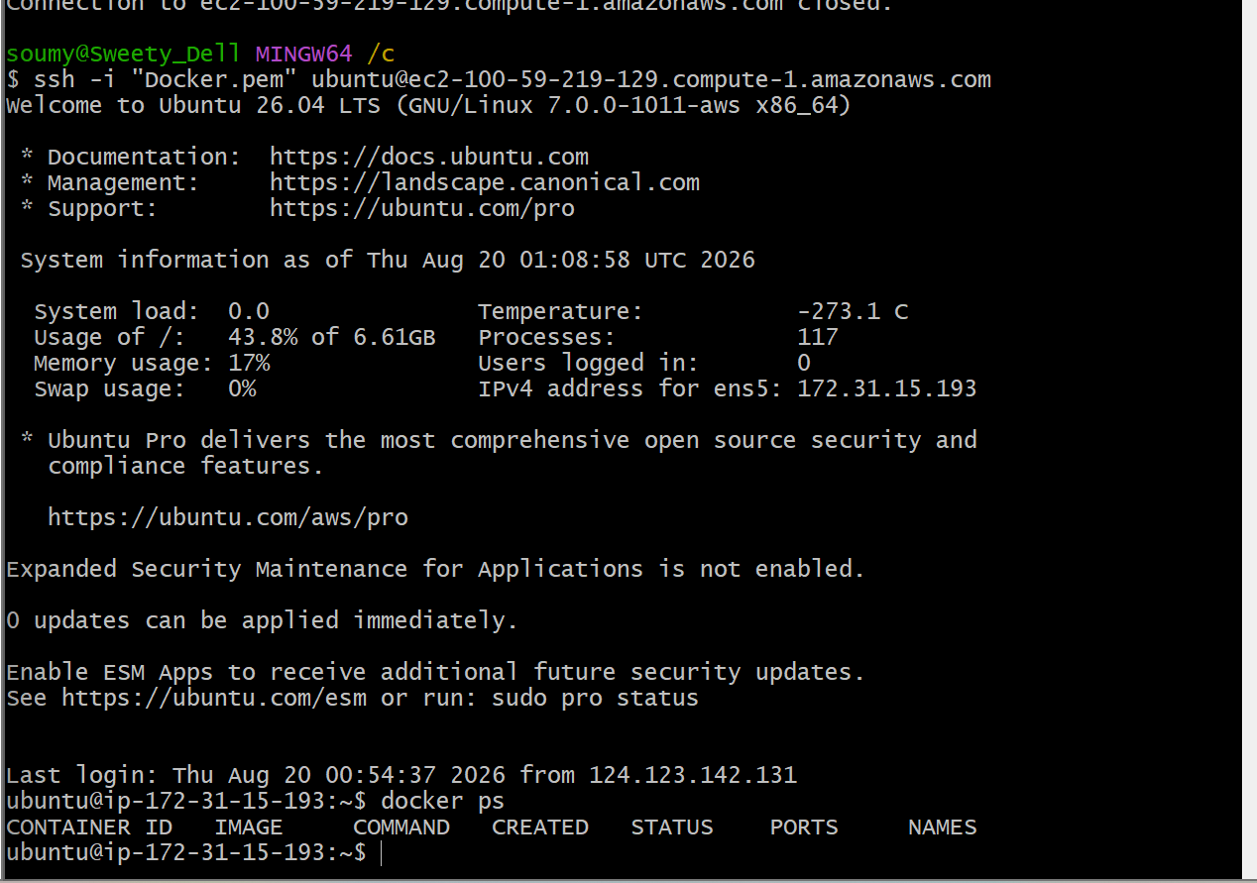
Pull the 5 images
- Nginx
- docker pull nginx
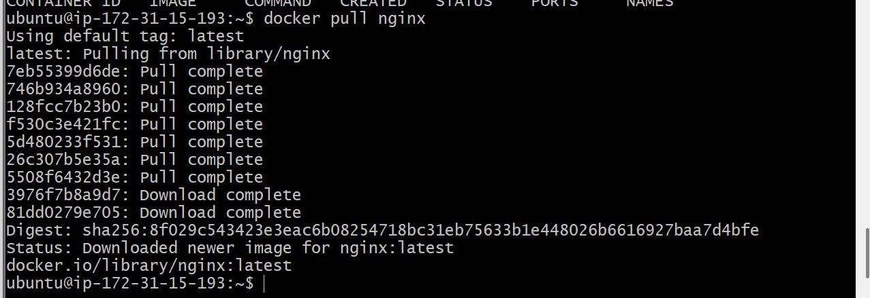
- Apache Tomcat
- docker pull tomcat
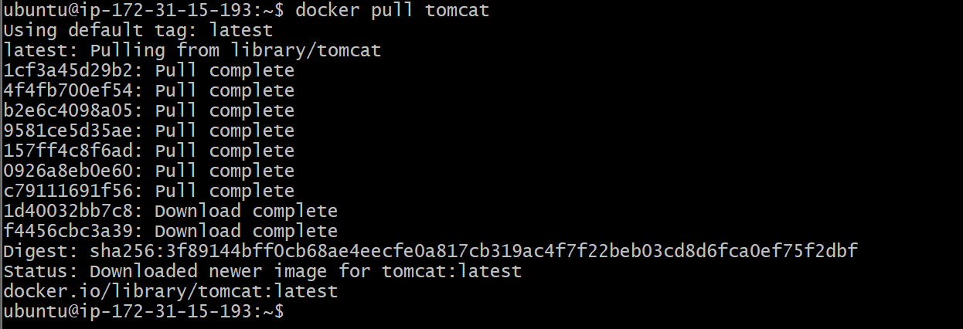
- Ubuntu
- docker pull ubuntu
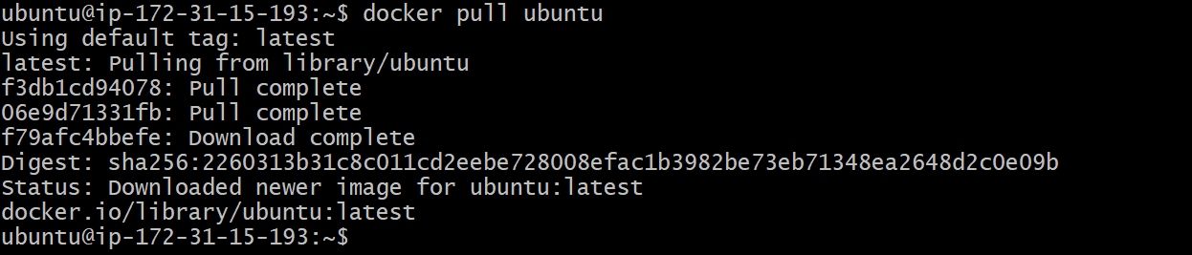
- Jenkins
- docker pull jenkins/Jenkins
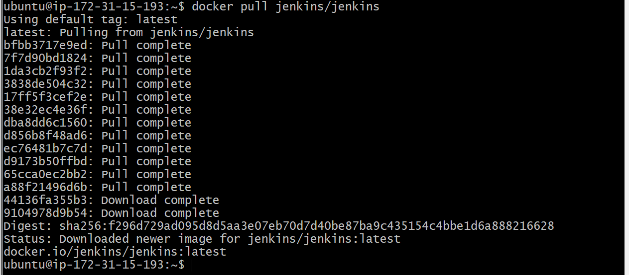
- SonarQube
- docker pull sonarqube
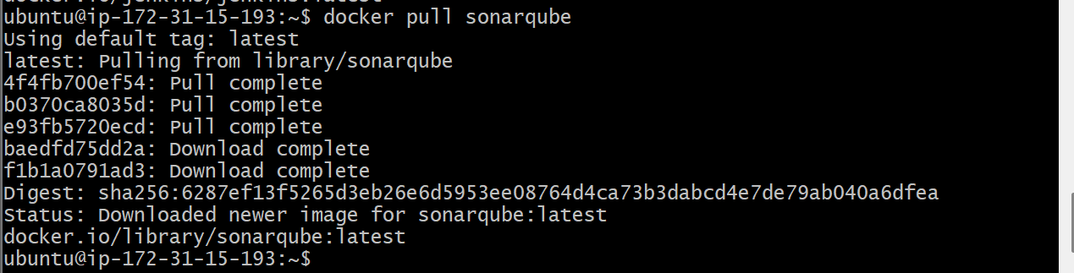
- Verify all 5 images
- docker images
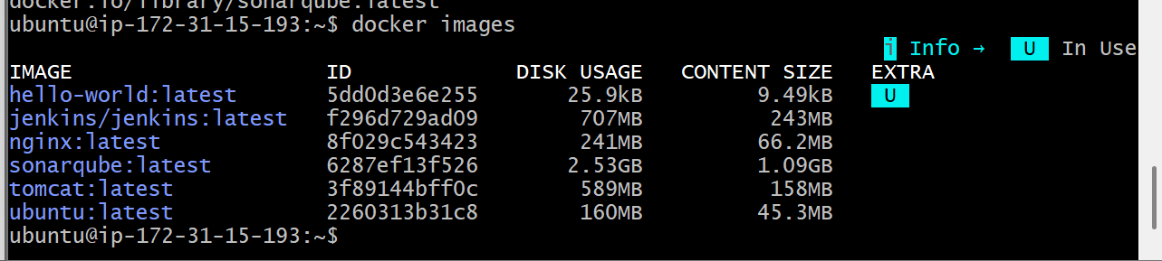
- Run nginx container and expose on port 81.

Since the Nginx image is already pulled, run:
docker run -d --name nginx-container -p 81:80 nginx
What does -p 81:80 mean?
Host port : Container port
81 : 80
- 81 → port on your EC2/Linux machine
- 80 → Nginx port inside the container
- -d → runs the container in the background
- --name nginx-container → gives the container a name
1. Check the container
docker ps
You should see:
CONTAINER ID IMAGE PORTS
xxxxxx nginx 0.0.0.0:81->80/tcp
2. Test locally
curl http://localhost:81
You should get the Nginx welcome page HTML.
3. If this is an AWS EC2 instance
Make sure your EC2 Security Group allows:
Type: Custom TCP
Port: 81
Source: 0.0.0.0/0
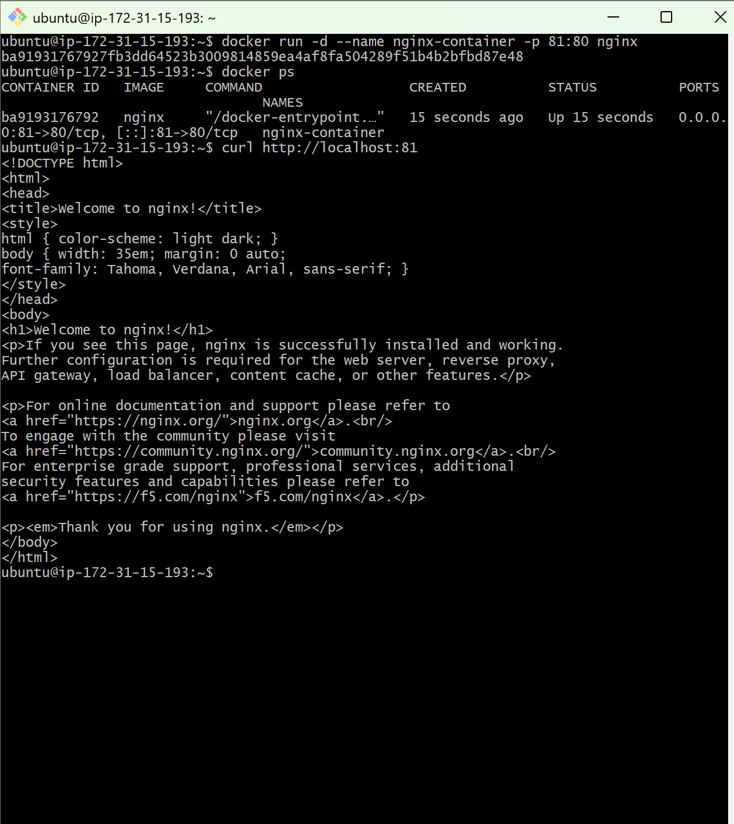
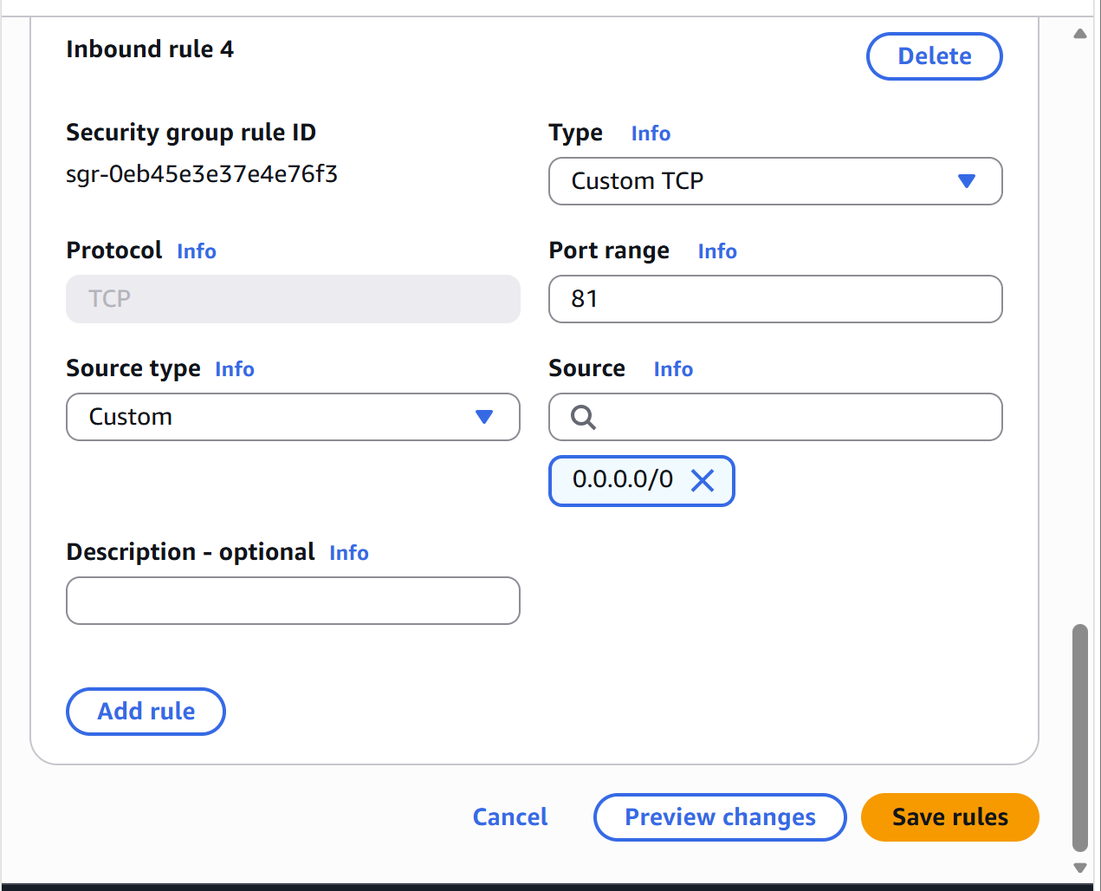
Then open:
http://YOUR-EC2-PUBLIC-IP:81
You should see Welcome to nginx!

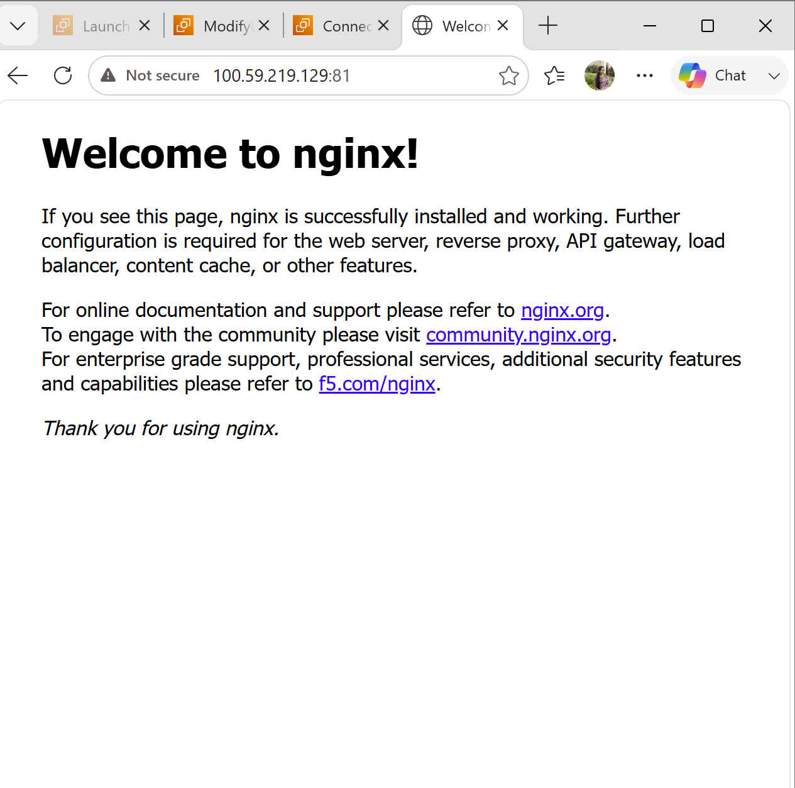

- Delete the Apache tomcat image from local.
1. Delete the Apache Tomcat image from local

First, check the Tomcat image name:

docker images

You should see something like:

REPOSITORY TAG IMAGE ID
tomcat latest xxxxxxxx

Then delete it:

docker rmi tomcat
Verify
docker images

The tomcat image should no longer appear.
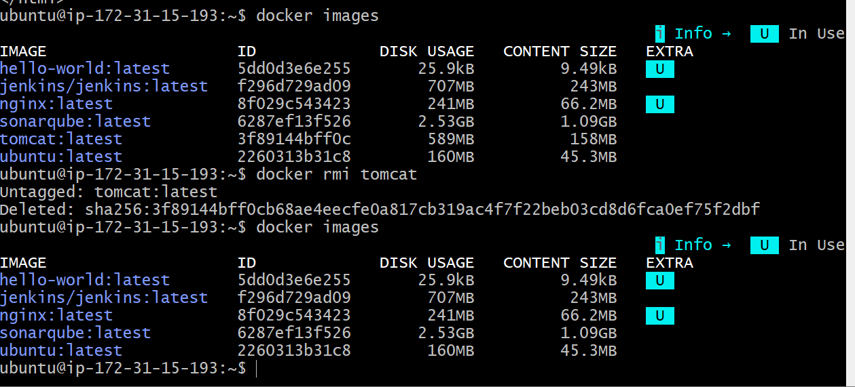
- Inspect the Jenkins image, SonarQube image.
Use docker inspect to view detailed information about an image.

Inspect Jenkins image
docker inspect jenkins/jenkins
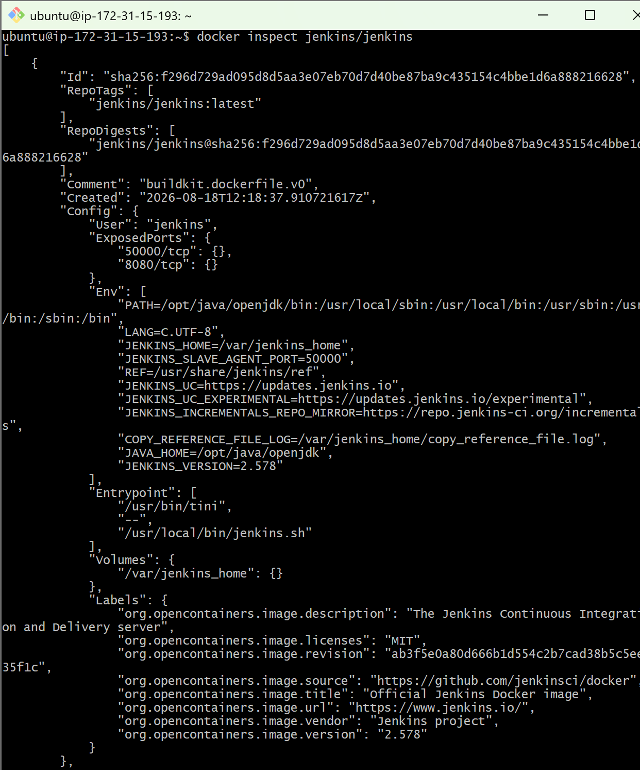

Inspect SonarQube image
docker inspect sonarqube
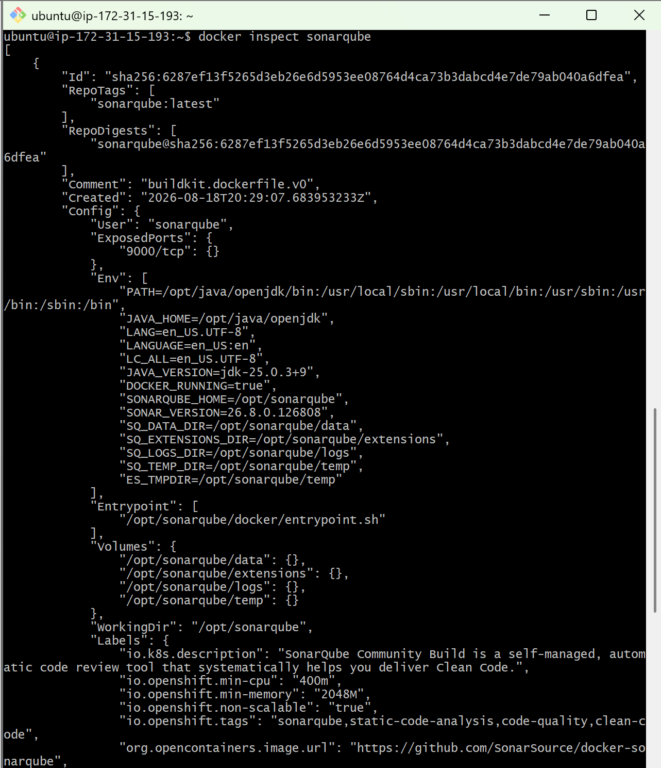
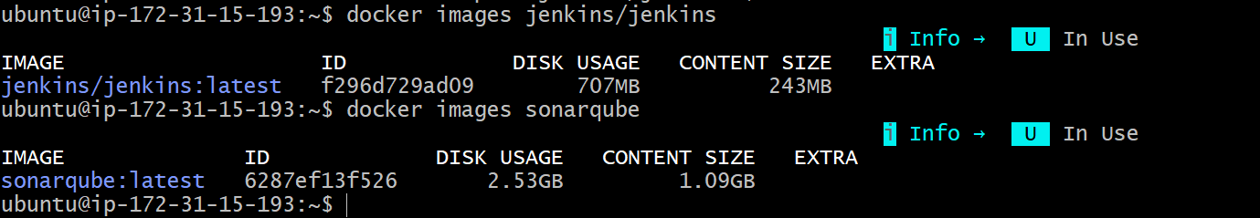
- Run Jenkins container and run one sample job.
Step 1: Run Jenkins container
docker run -d \
--name jenkins \
-p 8080:8080 \
-p 50000:50000 \
jenkins/jenkins:lts
Check that it is running:
docker ps
You should see:
jenkins/jenkins:lts 0.0.0.0:8080->8080/tcp
Step 2: Get the initial Jenkins password
Run:
docker exec jenkins cat /var/jenkins_home/secrets/initialAdminPassword
Copy the password shown.
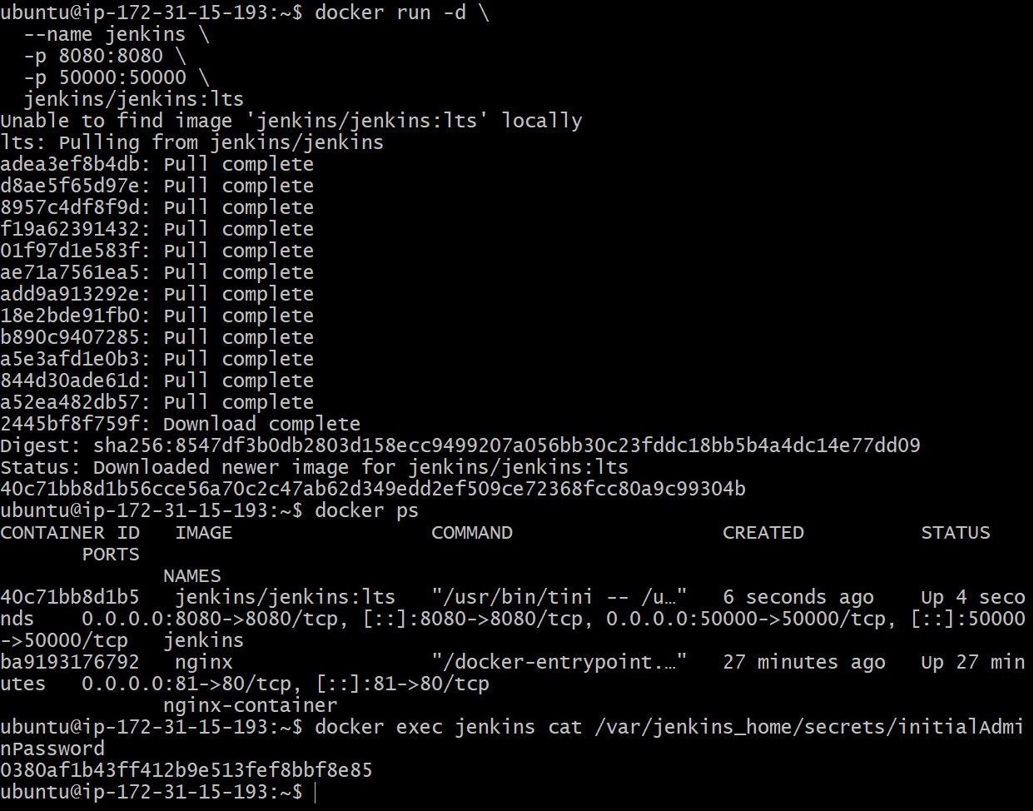
Step 3: Open Jenkins
If you're running Docker on an EC2 instance, open:
http://YOUR-EC2-PUBLIC-IP:8080
http://100.59.219.129:8080/
Make sure the EC2 Security Group allows TCP 8080.
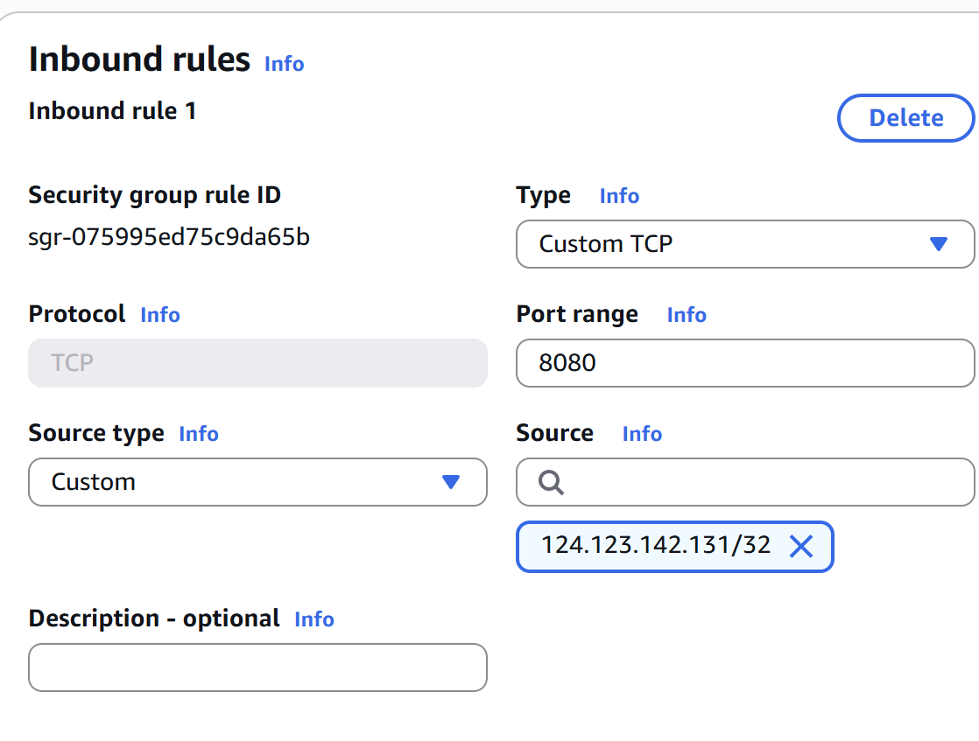
On the Jenkins setup page:
- Enter the initial password.
- Click Install suggested plugins.
- Create your Jenkins admin user.
- Finish the setup.
Step 4: Create a sample job
In Jenkins:
Dashboard → New Item
Enter:
Sample-Job
Select:
Freestyle project
Click OK.
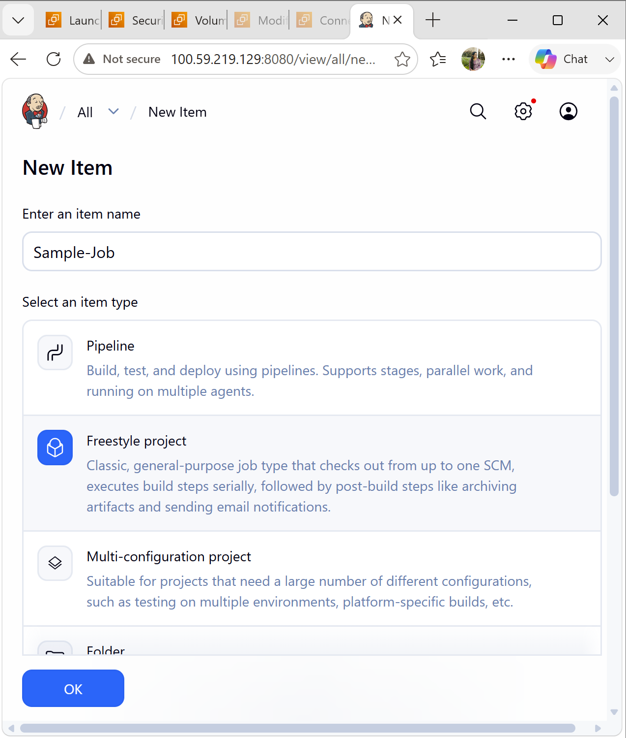
Step 5: Add a sample shell command
Go to:
Build Steps → Add build step → Execute shell
Enter:
echo "Hello from Jenkins Docker Container"
echo "Docker Jenkins Sample Job"
date
Click Save.
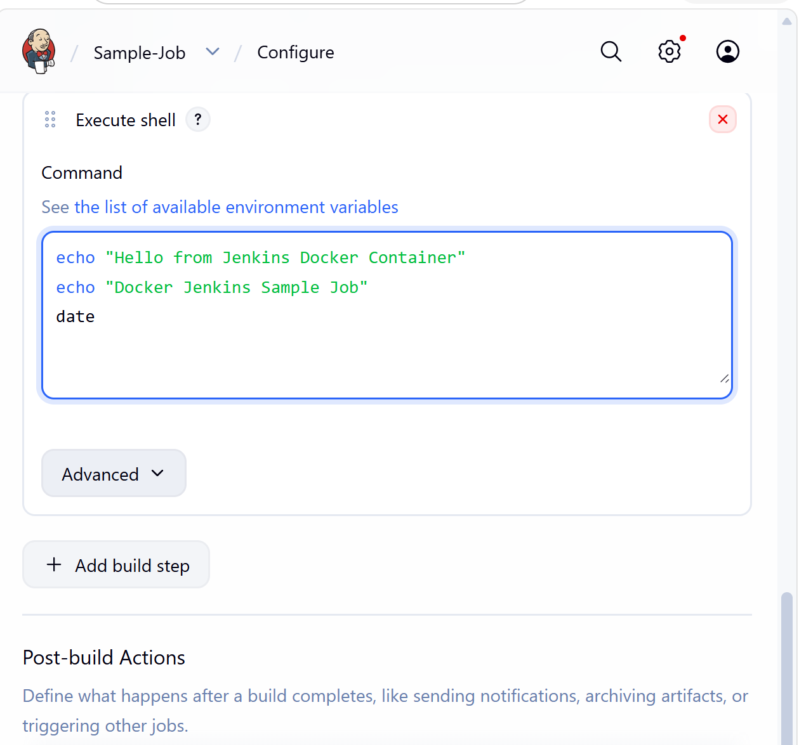
Step 6: Run the job
Click:
Build Now
You should see:
Build #1
Click:
#1 → Console Output
You should see something similar to:
Hello from Jenkins Docker Container
Docker Jenkins Sample Job
Thu Aug 20 ...
Finished: SUCCESS
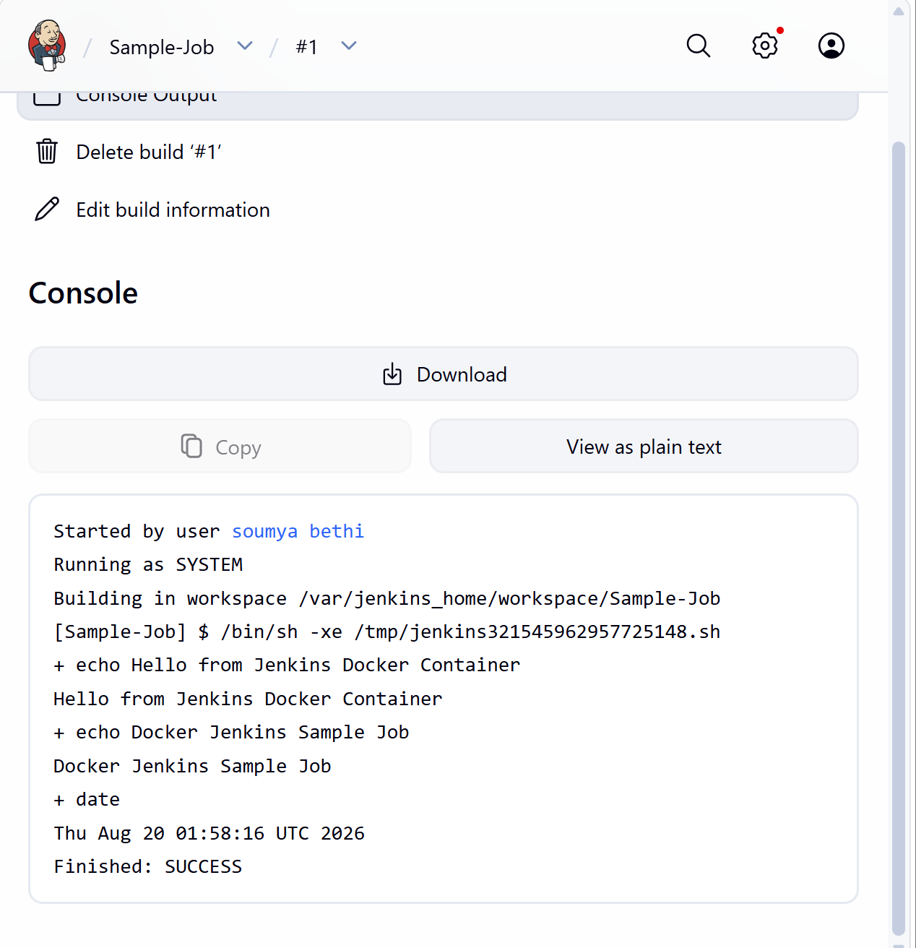
Step 7: Verify from Docker
On your Linux machine:
docker ps
You should see the Jenkins container running.
You can also check its logs:
docker logs jenkins
